**t r**

**o**

**p**

**Re**

**t**

**c**

**e**

**j**

**o**

**Pr**

**i**

**n**

**i**

**Title:**

Book Recommendation System

Mini Project in Informatics with a

specialization in Data Mining/Machine learning/ deep learning,

Student:

D20B 37 Mikil Lalwani

D20B 56 Nilay Pophalkar

D20B 58 Sanskruti Punyarthi

D20B 61 Shree Samal

Student code:

Course: IT734A

Autumn term/Spring term Year

Submission: 2023-10-09

**Abstract**

Book recommendation systems are becoming more popular and more people are turn-

ing to digital platforms to find new books. These systems use algorithms to analyze users' reading history, preferences, and other factors to create personalized recommendations.

Clustering, content filtering and hybrid methods are the most commonly used techniques in book recognition. These systems can benefit readers and businesses by providing per-sonalized recommendations and increasing book sales. However, the accuracy of these recommendations depends on the quality and quantity of data available and the results of the algorithms used. In this summary, we provide a brief overview of book recommendation systems and their benefits.

i

**Contents**

**1 Introduction 1**

1.1 Research questions/hypotheses: . . . . . . . . . . . . . . . . . . . . . . . 1

**2 Background 2**

**3 Data 3**

3.1 Data preparation . . . . . . . . . . . . . . . . . . . . . . . . . . . . . . 3

**4 Approach 4**

**5 Results 5**

**6 Discussion 5**

6.1 Limitations and Challenges . . . . . . . . . . . . . . . . . . . . . . . . 5

**7 Conclusion 6**

**8 Reflections on own work 7**

**A Appendices 8**

**1. Introduction**

In today’s world, with an overwhelming number of books to choose from, it can be a

challenge to find the right book that suits our interests and preferences. That’s why

We have developed a book recommendation system that makes it easier for you to find books that you will love.Our book recommendation system is based on machine learning algorithms that analyze your reading history, as well as your personal preferences and interests. The system uses this information to recommend books that are similar to the ones you’ve enjoyed in the past or books that are aligned with your interests.To use our book recommendation system, all you have to do is create a profile and fill out a short survey about your reading preferences. The system will then generate a list of recommended books that you can browse through.

**1.1 Research questions/hypotheses**

**Effectiveness and Accuracy:**

How accurate is the book recommendation system in predicting user preferences?

Can the recommendation system effectively suggest books that users are likely to enjoy?

**Personalization:**

To what extent does personalization improve the user's satisfaction with book recommendations?

How can the system adapt to changing user preferences over time?

**Diversity:**

Does the recommendation system balance between suggesting popular and niche books to users?

How can diversity in book recommendations be measured and optimized?

**User Feedback:**

How do user ratings, reviews, and feedback impact the quality of book recommendations?

Can the system effectively incorporate user feedback into its recommendations?

**2. Background**

The traditional book buying experience can be overwhelming and time-consuming for readers, particularly with the vast selection of books available. This often results in users not being able to find books that match their interests and preferences, leading to a less satisfying reading experience.

To address this problem, the book recommendation system is designed to provide personalized and relevant book recommendations to users based on their reading history, preferences, and other relevant factors. However, designing an effective book recommendation system can be challenging due to issues such as data privacy, ethical concerns related to algorithmic bias.

**Literature Survey:**

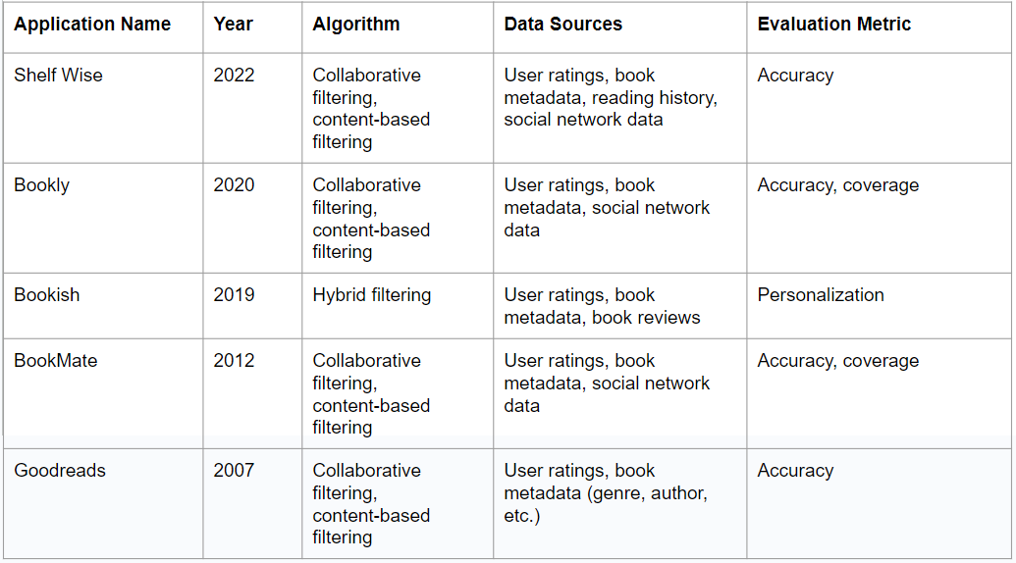

**3. Data**

**Description:**

The Goodreads Book Review Dataset is a comprehensive collection of data related to books, authors, and user interactions on the Goodreads platform. It encompasses a wide range of information that can be used for various research and analytical purposes related to literature and reading habits. Here's a breakdown of what the dataset might contain:

**Book Information:**

1. Title
2. Author(s)
3. ISBN (International Standard Book Number)
4. Publication Year
5. Genre/Category
6. Description/Summary

**User Data:**

1. User IDs
2. Usernames
3. Location (if available)
4. Age (if available)
5. Book Ratings:
6. User ratings (e.g., on a scale of 1 to 5 stars)
7. Average rating for each book
8. Total number of ratings

**Book Reviews:**

1. User-written reviews of books
2. Review text
3. Review date
4. Review sentiment (positive, neutral, negative)
5. Book Recommendations:
6. Books recommended to users based on their reading history

**Author Information:**

1. Author biographies
2. Other books by the same author

**User Interactions:**

1. Friendships or connections between users
2. User comments on reviews
3. User-generated book lists (e.g., "To-Read" lists)

**Additional Data:**

1. Book cover images
2. Edition information (e.g., hardcover, paperback)

**3.1 Data preparation**

**Dataset Cleaning Description:**

The dataset cleaning process for the Goodreads Book Review Dataset involved a series of steps to ensure that the data is consistent, reliable, and ready for further analysis or modeling. Here's a detailed description of each step:

**Handling Missing Values:**

Identified and addressed missing values in the dataset, which may have included null values or placeholders.

Techniques such as imputation or removal of rows/columns with missing data were applied to handle these gaps.

**Label Encoding of String Values:**

Converted categorical or string-based data (e.g., book titles, author names, user locations) into numerical representations through label encoding.

Each unique string value was assigned a unique numerical label, simplifying the dataset for analysis.

**Duplicate Removal:**

Detected and removed duplicate rows from the dataset to ensure that each data point is unique.

Duplicates may arise due to data collection errors or inconsistencies.

**Data Type Conversion:**

Ensured that the data types of each column were appropriate for analysis.

For example, dates were converted to a standardized date format, and numeric values were cast to the appropriate data type.

**Data Standardization:**

Standardized data values to maintain consistency throughout the dataset.

This may include converting text to lowercase, removing extra whitespaces, and normalizing data formats.

**Outlier Detection and Handling (if applicable):**

Identified outliers or extreme values in numerical data columns.

Employed techniques like z-score or IQR (Interquartile Range) to detect and potentially handle outliers.

**4. Approach**

**Flowchart:**

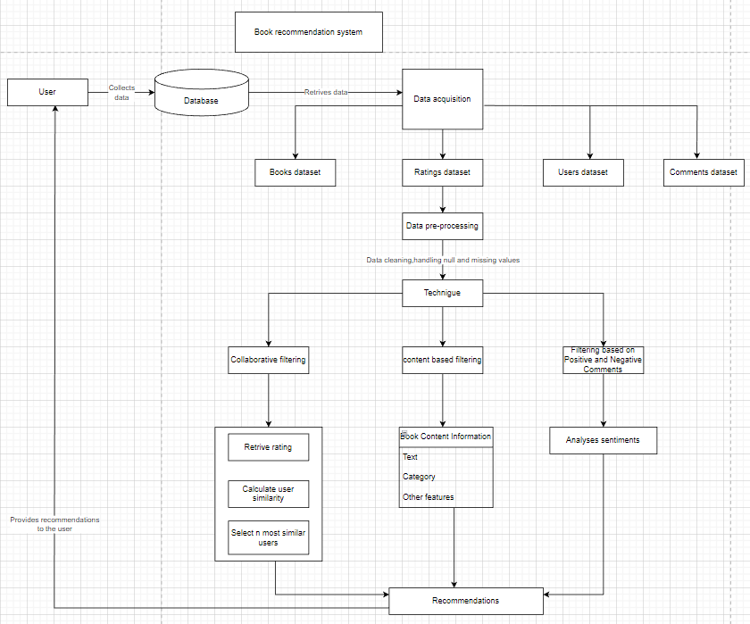

**Algorithms:**

1. **Collaborative filtering:**

The book recommendation system has collaborative filtering to generate recom-

mendations based on the user’s ratings. Collaborative filtering is a technique that

identifies similar users and recommends books based on the books that they have

enjoyed. To implement collaborative filtering, first a pivot table is created that shows the relation between the user and the user ratings. This pivot table consists of rows representing the users and columns representing the books, with the cell values representing the ratings given by the users.

Using this pivot table, similarity between users based on their rating patterns is

calculated using the cosine similarity algorithm. The cosine similarity algorithm is

used to calculate the similarity between two vectors, in this case, the vectors of user

ratings.

Once the similarity between users is calculated, the users with the most similar

rating patterns to the user for whom recommendations are generated needs to be

identified. Then books are recommended that the similar users have enjoyed and

that the target user has not read yet. This way, recommendations based on the

user’s ratings and the ratings of similar users are generated.

**2. Content-based filtering:**

Content based recommendation is useful for recommendation for new users .If user 1 reads book a and likes it and user 2 reads book a and also likes it and he also reads book b then book b will be recommended to user 1 as their choices are similar.

The book recommendation system, uses the cosine similarity algorithm to generate

recommendations based on the book’s attributes such as genre, author, and key-

words. The cosine similarity algorithm is a technique used to measure the similarity

between two vectors, in this case, the book vectors and the user vectors.

The book vectors are constructed based on the attributes of each book, such as

genre, author, and keywords. The user vectors are constructed based on the books the user has enjoyed in the past. By comparing the book vectors with the user vectors, the cosine similarity algorithm calculates the similarity between the two vectors, which indicates how likely the user is to enjoy the recommended book. The cosine similarity algorithm works by measuring the cosine of the angle between two vectors. A cosine similarity score of 1 indicates that the two vectors are identical, while a score of 0 indicates that they have no similarity.

This system, uses cosine similarity algorithm to recommend books with similar

attributes to those the user has enjoyed in the past. By analyzing the attributes

of the books the user has enjoyed, we can identify the key features that the user

prefers and find books with similar attributes to recommend.

**3. Natural language processing:**

Sentiment analysis is a technique used in natural language processing (NLP) to

determine the emotional tone of a piece of text. In our book recommendation

system, we used the sentiment intensity analyzer module to determine whether the

comments on a book are positive or negative.

The sentiment intensity analyzer is a tool that uses a lexicon-based approach to

assign a sentiment score to a given piece of text. The lexicon contains a list of words that are associated with either a positive or negative sentiment. The sentiment score is calculated by analyzing the intensity of each word’s sentiment and combining them to give an overall score. The sentiment score ranges from -1 (negative sentiment) to +1 (positive sentiment), with 0 indicating a neutral sentiment.

The recommendation system uses the sentiment intensity analyzer to analyze the

comments on each book.

**5. Results**

**Content based recommendation:**

The system is designed to suggest books to users based on their ratings and it also performs processing on the sentiment of their comments whether they are negative or positive comments. It utilizes a content-based recommendation system for books which uses the characteristics of books to recommend similar books to users. The system relies on analyzing the content of books, including the text of the book, the author, genre, and other metadata, to identify books that are similar to each other. We used the description and the title of the books to create a model using count vectorizer and cosine similarity to recommend books to users to analyze the text data and determine the sentiment of the comments. This allows the system to provide personalized book recommendations that are more likely to align with the user’s interests and preferences.

**Collaborative recommendation:**

For the collaborative recommendation system we use the ratings provided by the users for the books and use cosine similarity to identify top books which are similar to our input.

**6. Discussion**

**Discussion:**

The project described above involves the implementation of both content-based and collaborative recommendation systems for suggesting books to users based on their preferences and ratings. Each approach has its strengths and limitations, and combining them can provide a more robust recommendation system. Here's a discussion of the key aspects and implications of the project:

**1. Content-Based Recommendation:**

- **Strengths:** Content-based recommendation systems excel at providing personalized recommendations by analyzing the characteristics of the items (in this case, books). Using count vectorization and cosine similarity to analyze the title and description of books is a common and effective approach. This method allows the system to suggest books with similar content, making it suitable for users who prefer books of a specific genre, author, or topic.

- **Limitations:** Content-based systems may struggle with recommending diverse content or introducing users to entirely new genres or authors. They rely heavily on the features used for content analysis, and if the available data is limited, recommendations may become repetitive.

**2. Sentiment Analysis:**

- **Strengths:** Incorporating sentiment analysis of user comments is a valuable addition to the content-based recommendation system. It helps in identifying the emotional tone of reviews, allowing the system to consider not only the content but also user sentiments when making recommendations.

- **Limitations:** Sentiment analysis can be challenging, as it may not capture nuances in user feedback accurately. Additionally, negative sentiments may indicate strong opinions but not necessarily a dislike for the book. Fine-tuning sentiment analysis can improve its accuracy.

**3. Collaborative Recommendation:**

- **Strengths:** Collaborative recommendation systems leverage user interactions, such as ratings, to identify patterns and similarities among users. Cosine similarity is a commonly used technique for finding similar users and recommending items they have liked. This approach can introduce users to books they might not have discovered through content-based methods.

- **Limitations:** Collaborative systems may face challenges when dealing with new users (cold start problem) or recommending items with limited user ratings. Privacy concerns regarding user data and the need for a critical mass of users and ratings are also considerations.

**6.1 Limitations and Challenges**

What could have been investigated if given more time? What have been difficult when solving the problem and getting answers for your research questions/hypotheses?

**7. Conclusion**

The book recommendation system developed is based on cosine similarity, which is a common technique used in natural language processing to measure the similarity between two documents. The system takes as input a user’s book of interest and generates personalized book recommendations based on the similarity between the user’s past readings and the content of other books. The system is designed to provide users with relevant and diverse book recommendations that match their interests and preferences. It uses a combination of book metadata, such as genre, author, and publication year, and the con- tent of the book, such as keywords and topics, to calculate the similarity between books. The system also takes into account the user’s ratings and reviews of books, to provide more personalized recommendations. Overall, the book recommendation system provides an efficient and effective way to help users find new books that match their interests and preferences. The use of cosine similarity and the incorporation of user feedback allows for a more personalized and engaging user experience.

**8. Reflections on own work**

**1. Scoping the Problem:**

How we Decided to Scope (and/or Re-scope) the Problem:

* Initially, I started with a broad problem statement: "Build a book recommendation system."
* As the project progressed and I gained access to the data, I realized the dataset contained valuable information such as user ratings, book descriptions, and sentiment from user comments.
* To leverage this data effectively, I decided to scope the problem more narrowly into two main recommendation systems: content-based and collaborative.
* This scoping allowed for a more focused approach in utilizing available data to make recommendations based on book content and user interactions.

Searching for Knowledge on Problem Scoping:

* I researched articles, academic papers, and online tutorials related to recommendation systems, content-based and collaborative filtering methods, and sentiment analysis.
* I examined case studies and real-world examples of book recommendation systems to gain insights into best practices and scoping.
* I consulted forums, such as Stack Overflow and data science communities, to seek advice and solutions for specific challenges.

Implementation, Testing, and Validation:

* For the content-based recommendation system, I implemented text analysis techniques such as count vectorization and cosine similarity to measure text similarity between books.
* I performed testing by splitting the dataset into training and testing sets to evaluate the model's performance.
* Evaluation metrics, such as Mean Absolute Error (MAE) or Root Mean Square Error (RMSE) for ratings, and precision and recall for sentiment analysis, were used to validate the results.

Sources for Progress:

* Online courses and tutorials on machine learning and natural language processing provided guidance on implementing the algorithms.
* Academic papers on recommendation systems offered insights into state-of-the-art approaches.
* Collaboration with peers and mentors provided valuable feedback and alternative viewpoints.
* Open-source libraries and frameworks like scikit-learn and NLTK accelerated implementation and experimentation.

**2. What we Would Do Differently:**

* If starting over, I would invest more time upfront in understanding the dataset thoroughly. This includes assessing the quality of the data, identifying any anomalies or inconsistencies, and cleaning it effectively.
* To understand the problem faster, I would prioritize exploratory data analysis (EDA) to uncover patterns and gain insights into user behavior and book characteristics.
* I would consider incorporating additional data sources, such as book cover images or user demographics, if available, to enhance recommendation quality and personalization.
* I would place a greater emphasis on user feedback and iterative model improvement to fine-tune the recommendation algorithms.
* Ethical considerations and user privacy would be a top priority from the beginning, ensuring that user data is protected and the recommendation system is transparent and fair.
* Continuous monitoring of user satisfaction and system performance would be integrated into the development process to make adjustments as needed.

**A. Appendices**

[1] J. L. Herlocker, J. A. Konstan, L. G. Terveen, and J. T. Riedl, “Evaluating

collaborative filtering recommender systems,” ACM Trans. Inf. Syst., vol. 22,

no. 1, pp. 5–53, Jan. 2004.

[2] Yonghong Tian, College Library Personalized Recommendation System Based

on Hybrid Recommendation Algorithm, July 2019.

[3] Kurmashov, Online Book Recommendation System, September 2015.

[4] Item Recommendation on Monotonic Behavior Chains.